Department of Computer Science and Engineering
The University of Texas at Arlington

Team: Ink3D
Project: 3-D Printer Fabrication System
Team Members:
Daniel lain
Timothy Edmonson
Shawn Simonson
Jesse Bowles

Last Updated: 9/23/2013 7:11 pm

Table of Contents
Contents
Table of Contents 2
Document Revision History 6
List of Figures 7
List of Tables 8
1. Product Concept 9
1.1 Purpose and Use 9
1.2 Intended Audience 9
2. Product Description and Functional Overview 10
2.1 Features and Functions 10
2.2 External Inputs and Outputs 11
2.3 Product Interfaces 13
3. Customer Requirements 15
3.1 STL File Input 15
3.2 Graphical User Interface 15
3.3 Generate Machine Instructions 15
3.4 Issue Machine Instructions 16
3.5 Monitor Temperature 16
3.6 Monitor Position 16
3.7 Adhere to the Material Constraints 17
3.8 Identify Materials 17
3.9 Identify Shapes 17
3.10 Determine Shape of Support Material Structure 17
3.11 Create Printing Path 18
3.12 Database Interface 18
3.13 Store & Load Material Records 18
3.14 Slice Geometry into Thickness Levels 19
3.15 Monitor Flow Sensors 19
3.16 Monitor Door Switch 19
3.17 Allow for UV Head Polymerization 19
3.18 Sparsity and Density Controls 20
3.19 Graphical Object Models 20
4. Packaging Requirements 21
4.1 Software Installer 21
4.2 Client Software to Printer Connection 21
4.3 User Manual 21
5. Performance Requirements 23
5.1 Startup Time 23
5.2 STL Import Time 23
5.3 Object Processing Time 23
5.4 GUI Responsiveness 24
5.5 Real Time Sensor Monitoring 24
6. Safety Requirements 25
6.1 Temperature Cutoff Threshold 25
6.2 Printing Area Restrictions 25
7. Maintenance and Support Requirements 26
7.1 Client Software Manual 26
7.2 Intermediary Machine Software Manual 26
7.3 Intermediary Machine Hardware Manual 26
8. Other Requirements 28
8.1 Material Database 28
8.2 Abstract Hardware Interface 28
8.3 Modular and Scalable Design 28
9. Acceptance Criteria 29
9.1 Verify that system reads STL files 29
9.2 Verify the user interface 29
9.3 Verify the system prints a model 29
9.4 Verify the system stops printing of out of operational range 29
10. Use Cases 30
10.1 Upload STL File to System 30
10.2 Print 3D Object 30
10.3 Add New Material to Database 30
11. Feasibility Assessment 32
11.1 Scope Analysis 32
11.2 Research 33
11.3 Technical Analysis 33
11.4 Cost Analysis 34
11.5 Resource Analysis 35
11.6 Schedule Analysis 35
11.6.1 Size Estimate – Function Points 36
11.6.2 Effort Estimate – Jones First Order Estimation 38
11.6.3 Size Estimate – Lines of Code 38
11.6.4 Effort Estimate – CoCoMo 39
11.6.5 Effort Estimate – Estimate Comparison 39
12. Future Items 40
12. 1 Customer Requirement 3.17 – Monitor Door Switch 40
12. 2 Customer Requirement 3.19 – Sparcity and Density Controls 40
12. 2 Customer Requirement 3.20 – Graphical Object Models 40

Document Revision History
Revision Number | Revision Date | Description | Rationale
0.1 | 9/23/13 | Initial

List of Figures
Figure # Title Page #
1-1 System Components 7
2-1 System Concept 11
2-2 3D Printing Interface 14
2-3 Material Data Interface 14
10-1 Use Case: 3D Printer Operations 32

List of Tables
Figure # Title Page #
2.2 External Inputs and Outputs 11
11.1 Function Points Analysis 37
11.2 Influence Multipliers 38
11.3 Jones First Order Estimation 39
11.4 Size Estimate – Lines of Code 39
11.5 CoCoMo Estimate 40
11.6 Estimate Comparison 40

1. Product Concept
This section describes the purpose, use and intended audience for the 3-D Printer Fabrication System product. The printer will allow items to be produced using an additive material process. The 3-D Printer Fabrication System will produce items consisting of more than one material of possibly very different characteristics.

Purpose and Use
The 3-D Printer Fabrication System will provide an interface for converting standard stereo lithography or STL files into realized items. The system will use a simple graphical user interface to select the files and materials to be used in the production of the 3D model. When the file is loaded, the system will translate the STL file in to a series of layers based on the granularity of the materials to be used in the final build. The system will then use the layers to produce a series of paths for the print head to traverse to deposit the correct material to the specified location. From this series of steps, an instruction set will be produced for the printer to execute each path for every layer and material. Finally, the instructions will be issued to the printer and it will execute the commands producing the designed object that was described by the original STL file.

Intended Audience
The intended audience of the 3-D Printer Fabrication System is the research and medical fields. The initial device will be for Dr. Shiakolas who will be testing the unit with human compatible materials with the intent of making medical implements such as stints.

Figure 1-1 System Components

2. Product Description and Functional Overview
This section describes the functions of the 3-D Printer Fabrication System. The primary operational aspects of the product, from the perspective of end users, maintainers and administrators, are defined here. The key features and functions found in the 3-D Printer Fabrication System, as well as critical interactions and user interfaces are described in detail.

2.1 Features and Functions
The 3-D Printer Fabrication System contains a platform that is the base where the object desired is printed. Above the platform, an arm with multiple nozzles can move about the xyz axis and extrude the material that makes up the object. The 3-D Printer Fabrication System begins by accepting an STL file that contains the description of the object the user desires to be printed. After selecting the type of material(s) wanted for the object, the user confirms that the object is ready to be printed. The 3-D Printer Fabrication System reads the STL file and slices the described object into layers to formulate a path for each material. The 3-D Printer Fabrication System then calibrates the nozzle to the correct settings for the first material and begins printing the first layer. After a single material has been printed for that layer, the printer switches to the next material to be printed until finished with that layer. The 3-D Printer Fabrication System then formulates new paths for the next layer and starts the printing process again. This continues until the last layer is finished.
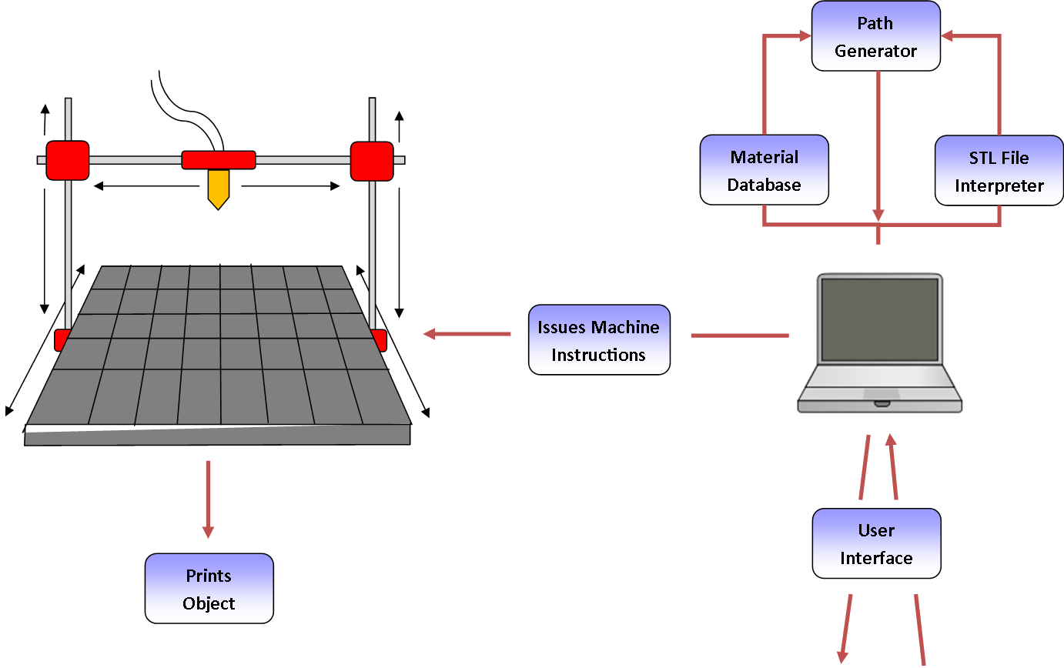
Figure 2-1: System Concept

2.2 External Inputs and Outputs
The 3-D Printer Fabrication System will take several inputs when a user begins the printing process. The model will be brought in using a common industry format such as STL or AMF. The 3-D Printer Fabrication System will need to read in several variables such as heat, position, and state. Below is a detailed listing of all inputs and outputs.
Type: | Name: | Description: | Use:
Input: | STL File | A file format used to store data about a 3D model. | The system will process this file to determine what the shape of the object we are printing is.
Input: | Material Data | Contains information necessary for printing with each material such as extrusion speed, temperature it should extrude at, and speed at which the nozzle can move. | The system stores this information in a small database and retrieves the info when it is ready to use that material. The material data is imperative for printing that material properly.
Input: | Selection | All the settings and options that must be defined before the printing can be done (e.g.: Can the material type be chosen by the user? Does the user determine which side the object lies on? Can the user control how many objects will be printed at once?) | The system at minimum will require a user to select an STL file of an object the user wants printed. More functionality might be added at a later date.
Input: | Start Printing | An interface option to begin printing. | The user presses this button after initializing what will be printed and the correct parameters for the material being used are in place.
Input: | Stop/Pause Printing | An interface option to end or pause printing after printing has started. | An option to halt printing can be useful in case of errors that are occurring that are not being caught by the system or if the user no longer desires the object to be printed.
Input: | Heat Sensor | A temperature gauge that monitors the temperature of the nozzle. | Each material being extruded for the print has a target temperature it must be at in order to print properly. The system needs sensors to verify that the temperature is correct, and make corrections to the heating when it is not.
Input: | Position Sensor | A sensor that tracks the position of the arm and nozzle. | The system needs a way to track the position of the nozzle and arm so that it can carry out the printing paths correctly.
Input: | Flow Sensor | A sensor that tracks how fast the material is extruding from the nozzle. | Each material requires a target flow speed in order to print properly with that material. The system uses the flow sensor to verify that the speed flow is correct, and make corrections when it is not.
Input: | Door Sensor | A sensor that tracks when the door is open or closed. | If the system uses a closed environment, the system would benefit from knowing when the environment is secure (closed door) or not (door is opened).
Output: | State Notification | A notification that lets the user know the state of the 3-D Printer Fabrication System. | Ensure the user knows the current state of the device.
Output: | Confirmation Message(s) | Any potential notification that the user should receive before the system begins printing the object. | The system should verify that what it is about to print is what the user wants. Proper verification can prevent wasting material and printing time.
Output: | Printed Object | The physical 3D object that is created by the system. | The system's primary goal is to print this object.

2.3 Product Interfaces
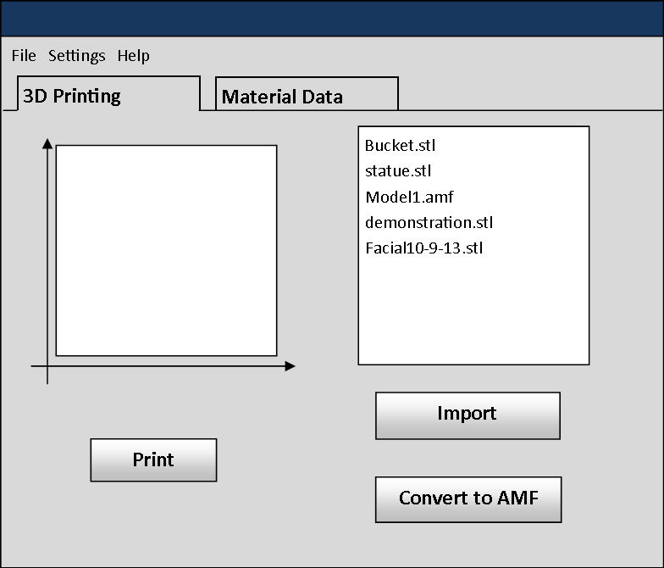
Figure 2-2: 3D Printing Interface
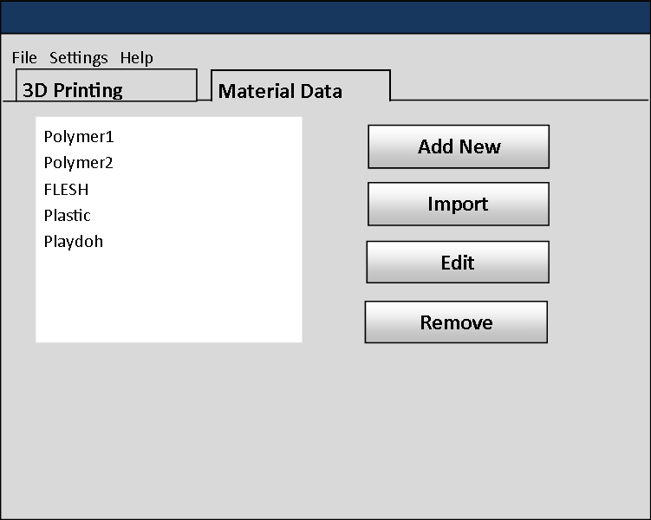
Figure 2-3: Material Data Interface

3. Customer Requirements
This section specifies the requirements provided by Dr. Panos Shiakolas who is the project’s sponsor and the intended audience of the 3-D Printer Fabrication System. The requirements in this section must be implemented in order for the product to function the way Dr. Shiakolas intends. The requirements in this section shall not be altered without the approval of Dr. Shiakolas and the members of the development team. These requirements deal with the user interface of the system as well as the functionality expected by the product’s audience.

3.1 STL File Input
3.1.1 Description: The system shall provide a way for the user to select an STL file and then input that STL file into the system for processing.
3.1.2 Source: Dr. Panos S. Shiakolas (Sponsor)
3.1.3 Constraints: The system must support multi-material objects but the STL file format does not support material information.
3.1.4 Standards: STL (STereo Lithography) File Format
3.1.5 Priority: 1 - Critical

3.2 Graphical User Interface
3.2.1 Description: The system shall provide a graphical user interface from which the user can import 3D models and initiate print operations. The GUI must be both intuitive and responsive. The GUI must be portable so that it can be used with the most current Windows, Linux, and Mac operating systems.
3.2.2 Source: Dr. Panos S. Shiakolas (Sponsor)
3.2.3 Constraints: None
3.2.4 Standards: Java Swing/AWT
3.2.5 Priority: 3 - Moderate

3.3 Generate Machine Instructions
3.3.1 Description: The system shall generate instructions needed by the printing hardware in order to print a given 3D object.
3.3.2 Source: Dr. Panos S. Shiakolas (Sponsor)
3.3.3 Constraints: The machine instruction set is currently undefined.
3.3.4 Standards: STL, AMF, GCode
3.3.5 Priority: 1 – Critical

3.4 Issue Machine Instructions
3.4.1 Description: The system shall issue generated machine instructions from the software component to the printing hardware component.
3.4.2 Source: Dr. Panos S. Shiakolas (Sponsor)
3.4.3 Constraints: The method of issuing machine instructions is currently undefined.
3.4.4 Standards: GCode
3.4.5 Priority: 1 – Critical

3.5 Monitor Temperature
3.5.1 Description: The system shall monitor input from heat sensors attached to the printing hardware. The temperature of each extruder’s nozzle must be monitored at all times to ensure that material is extruded at the proper temperature.
3.5.2 Source: Dr. Panos S. Shiakolas (Sponsor)
3.5.3 Constraints: In order to monitor the temperature of different extruder nozzles, the printing hardware must output information describing the temperature of each extruder nozzle.
3.5.4 Standards: None
3.6.5 Priority: 1 – Critical

3.6 Monitor Position
3.6.1 Description: The system shall monitor the position of the printing head at all times during operation. The system must be aware of the position of the printing head in order to adhere to a predefined printing path.
3.6.2 Source: Dr. Panos S. Shiakolas (Sponsor)
3.6.3 Constraints: In order for the printing head position to be monitored by the system, the printing hardware must output information describing the position of the printing head.
3.6.4 Standards: None
3.6.5 Priority: 1 – Critical

3.7 Adhere to the Material Constraints
3.7.1 Description: The system shall adhere to the material constraints that limit the movement speed, extrusion rate, and nozzle temperature. Different materials have different properties that the system must account for in order to produce a properly printed object.
3.7.2 Source: Dr. Panos S. Shiakolas (Sponsor)
3.7.3 Constraints: Information about the constraints for each material must be provided by the Mechanical Engineering team before our team can input them into the system.
3.7.4 Standards: None
3.7.5 Priority: 1 - Critical

3.8 Identify Materials
3.8.1 Description: The system shall identify every type of material that is being used for printing the 3D object.
3.8.2 Source: Dr. Panos S. Shiakolas (Sponsor)
3.8.3 Constraints: Modularization.
3.8.4 Standards: STL file (but possibly AMF?)
3.8.5 Priority: 1 - Critical

3.9 Identify Shapes
3.9.1 Description: The system shall identify the shape of the object being printed by dividing it into smaller shapes for each individual material used.
3.9.2 Source: Dr. Panos S. Shiakolas (Sponsor)
3.9.3 Constraints: Unification of multiple shapes with common materials.
3.9.4 Standards: STL file
3.9.5 Priority: 1 - Critical

3.10 Determine Shape of Support Material Structure
3.10.1 Description: The system shall determine the shape that the support material needs to be for stabilizing the 3D object as it is being printed. Without the support, the object could collapse during printing.
3.10.2 Source: Dr. Panos S. Shiakolas (Sponsor)
3.10.3 Constraints: Processing of voids.
3.10.4 Standards: None
3.10.5 Priority: 1 - Critical

3.11 Create Printing Path
3.11.1 Description: The system shall determine a route that the printing head must follow as it prints. This is to avoid collision between the head or arm and the object being printed.
3.11.2 Source: Dr. Panos S. Shiakolas (Sponsor)
3.11.3 Constraints: Cannot print two materials on the same path.
3.11.4 Standards: Gcode
3.11.5 Priority: 1 - Critical

3.12 Database Interface
3.12.1 Description: The system shall have an interface that allows the user to view what material is already stored in the database and enter new information for material not already stored.
3.12.2 Source: Tim Edmonson
3.12.3 Constraints: None
3.12.4 Standards: Java / Swing / AWT
3.12.5 Priority: 1 - Critical

3.13 Store & Load Material Records
3.13.1 Description: The system shall be able to load the material records in order to control the temperature, movement speed, and flow speed of the nozzle at the correct setting.
3.13.2 Source: Daniel Lain
3.13.3 Constraints: None
3.13.4 Standards: Must be able to be serialized.
3.13.5 Priority: 1 – Critical

3.14 Slice Geometry into Thickness Levels
3.14.1 Description: The system shall be able to process geometry in such a way as to generate sub-models of appropriate and customizable thickness such that the 3D printer can print each layer of the given thickness.
3.14.2 Source: Dr. Panos Shiakolis
3.14.3 Constraints: None
3.14.4 Standards: None
3.14.5 Priority: 1 – Critical

3.15 Monitor Flow Sensors
3.15.1 Description: The system shall monitor nozzle flow sensors and be able to maintain and adjust accordingly if the sensor begins to read out of bounds.
3.15.2 Source: Shawn Simonson
3.15.3 Constraints: None
3.15.4 Standards: None
3.15.5 Priority: 1 – Critical

3.16 Monitor Door Switch
3.16.1 Description: The system shall be able to use a sensor to monitor the 3D printer’s access door. Appropriate action should be taken when the door is opened during printing and ensure the door is closed prior to starting to print.
3.16.2 Source: Shawn Simonson
3.16.3 Constraints: None
3.17.4 Standards: None
3.16.5 Priority: 5 – Future

3.17 Allow for UV Head Polymerization
3.17.1 Description: The head shall be able to use UV light to cure or dry the extruded material. The system, therefore, shall accommodate the use of UV to be turned on and off such that the material can be cured.
3.17.2 Source: Dr. Panos Shiakolis
3.17.3 Constraints: The system shall allow for duplicate paths.
3.17.4 Standards: None
3.17.5 Priority: 1 – Critical

3.18 Sparsity and Density Controls
3.18.1 Description: The system shall allow for models to be processed in such a way that the geometry can be simplified or made more complex according to user specifications from any arbitrary model geometry.
3.18.2 Source: Dr. Panos Shiakolis
3.18.3 Constraints: Processing/Memory complexity.
3.18.4 Standards: None
3.18.5 Priority: 5 – Future

3.19 Graphical Object Models
3.19.1 Description: The system shall display a graphical model of the objects represented by imported STL files. The user will be able to drag the graphical model around on a virtual printer bed in order to specify the location on the printer bed where the object will be printed.
3.19.2 Source: Tim Edmondson
3.19.3 Constraints: This will require graphics processing and may make the GUI unresponsive.
3.19.4 Standards: None
3.19.5 Priority: 5 – Future

4. Packaging Requirements
This section describes the delivery and packaging of the 3-D Printer Fabrication System to the end-user. The software and hardware components of the system each have separate delivery and packing requirements. This document specifies the software system requirements; therefore this section specifies the software delivery and packaging requirements as well as the delivery and packaging requirements for the physical interface between the software and hardware.

4.1 Software Installer
4.1.1 Description: The client software shall be delivered as an executable installer.
4.1.2 Source: Dan Lain (Team Member)
4.1.3 Constraints: Multiple installers will have to be implemented to support multiple platforms.
4.1.4 Standards: Windows installer will be used to install on the Windows platform. Mac OS X installer will be used on the Mac platform. A Debian package will be used to install on the Linux platform.
4.1.5 Priority: 4 – Low

4.2 Client Software to Printer Connection
4.2.1 Description: The client software shall be connected to the printing hardware using a serial cable.
4.2.2 Source: Shawn Simonson (Team Member)
4.2.3 Constraints: The printing hardware must support USB to TTL.
4.2.4 Standards: USB to TTL is the standard connection between client software and 3D printer microcontrollers.
4.1.5 Priority: 1 – Critical

4.3 User Manual
4.3.1 Description: The system shall be delivered with a user manual. The user manual will include detailed instructions on how to operate the client software and how to properly connect the client software to the printer.
4.3.2 Source: Tim Edmondson (Team Member)
4.3.3 Constraints: None
4.3.4 Standards: None
4.3.5 Priority: 3 - Moderate

5. Performance Requirements
This section describes the performance requirements for the product. The system is required to be responsive to user interaction, process 3D models efficiently, and monitor sensors in real time.

5.1 Startup Time
5.1.1 Description: The client software shall start in a reasonable amount of time.
5.1.2 Source: Tim Edmondson (Team Member)
5.1.3 Constraints: None
5.1.4 Standards: None
5.1.5 Priority: 4 – Low

5.2 STL Import Time
5.2.1 Description: The client software shall import STL files in a reasonable amount of time.
5.2.2 Source: Tim Edmondson (Team Member)
5.2.3 Constraints: None
5.2.4 Standards: The STL file format will be imported.
5.2.5 Priority: 4 – Low

5.3 Object Processing Time
5.3.1 Description: The client software shall perform object processing and machine instruction generation in a reasonable amount of time.
5.3.2 Source: Tim Edmondson (Team Member)
5.3.3 Constraints: The geometric processing algorithms used to process objects must be efficient.
5.3.4 Standards: None
5.3.5 Priority: 4 – Low

5.4 GUI Responsiveness
5.4.1 Description: The graphical components of the user interface shall be responsive to user interaction.
5.4.2 Source: Tim Edmondson (Team Member)
5.4.3 Constraints: In order to achieve a responsive user interface, multi-thread processing may be required.
5.4.4 Standards: None
5.4.5 Priority: 3 – Moderate

5.5 Real Time Sensor Monitoring
5.5.1 Description: The system shall monitor data from sensors in real time during operation. The sensor data must be monitored in real time to ensure proper printer functionality as well as enforce safety systems.
5.5.2 Source: Tim Edmondson (Team Member)
5.5.3 Constraints: Constant monitoring of sensors could require expensive processing and memory resources.
5.5.4 Standards: None
5.5.5 Priority: 2 – High

6. Safety Requirements
This section specifies the requirements concerned with ensuring that the product functions in a safe manner. 3D printers extrude material at very high temperatures, which causes safety concerns. These safety concerns are addressed by the following requirements.

6.1 Temperature Cutoff Threshold
6.1.1 Description: The system shall include a temperature cutoff threshold for the printer head. If the temperature of the printer head reaches the cutoff temperature, the system will abort the operation and shut off the heating device.
6.1.2 Source: Tim Edmondson (Team Member)
6.1.3 Constraints: The system must be able to accurately monitor the temperature of each printing head.
6.1.4 Standards: None
6.1.5 Priority: 1 – Critical

6.2 Printing Area Restrictions
6.2.1 Description: The system shall only extrude material within a configured area. Material extruded by the printer will be at a high temperature and may cause harm to the printer’s surroundings; therefore it is important to ensure that the material is only extruded in a specified safe area.
6.2.2 Source: Tim Edmondson (Team Member)
6.2.3 Constraints: The dimensions of the printer’s safe printable area are not currently known.
6.2.4 Standards: None
6.2.5 Priority: 1 – Critical

7. Maintenance and Support Requirements
The primary components identified for support are the software used on the client-side machine, the software on the intermediary machine, and the hardware used for the intermediary machine. All support to be provided is in the form of documentation of the three components.

7.1 Client Software Manual
7.1.1 Description: A manual that details the operation of the client software shall be provided by the team. Here, “client software” is that software which is run on the workstation that generates machine G-Codes for the intermediary machine.
7.1.2 Source: Shawn Simonson
7.1.3 Constraints: The manual must detail common troubleshooting issues as well as provide basic usage instructions.
7.1.4 Standards: None
7.1.5 Priority: 1 – Critical

7.2 Intermediary Machine Software Manual
7.2.1 Description: A manual that details the operation of the intermediary machine software shall be provided by the team. Here, the “intermediary machine” is that machine which resides between the client workstation and the printer interface itself. This machine will be embedded in nature. The manual shall detail common troubleshooting issues as well as provide basic usage instructions.
7.2.2 Source: Shawn Simonson
7.2.3 Constraints: The manual must detail common troubleshooting issues as well as provide basic usage instructions.
7.2.4 Standards: None
7.2.5 Priority: 1 – Critical

7.3 Intermediary Machine Hardware Manual
7.3.1 Description: A manual that details the operation of the intermediary machine hardware. The manual shall detail common troubleshooting issues with the intermediary hardware as well as resolutions which detail resetting of the device.
7.3.2 Source: Shawn Simonson
7.3.3 Constraints: The manual must provide a basic hardware component level diagram and interface diagram.
7.3.4 Standards: None
7.3.5 Priority: 1 - Critical

8. Other Requirements
This section describes requirements that did not fit within the requirements sections above. These requirements deal with data management and modularity.

8.1 Material Database
8.1.1 Description: The system shall have a database that holds information about how the material is printed.
8.1.2 Source: Dr. Panos S. Shiakolas (Sponsor)
8.1.3 Constraints: None
8.1.4 Standards: Binary Text
8.1.5 Priority: 1 – Critical

8.2 Abstract Hardware Interface
8.2.1 Description: The system shall allow for multiple different printers and multiple different heads to be used with minimal or zero software change.
8.2.2 Source: Jesse Bowles
8.2.3 Constraints: The system must allow for different machine interfaces to be used.
8.2.4 Standards: None
8.2.5 Priority: 1 – Critical

8.3 Modular and Scalable Design
8.3.1 Description: The system shall be able to be used across multiple different types of printers, different types of printing beds, and different number and type of heads with minimal or zero coding effort required.
8.3.2 Source: Dr. Panos Shiakolis
8.3.3 Constraints: None
8.3.4 Standards: S.O.L.I.D. Design Principles
8.3.5 Priority: 1 – Critical

9. Acceptance Criteria
These acceptance criteria will be tested during the verification testing of the 3-D Printer Fabrication System project. The following are critical points in the functional success of the 3-D Printer Fabrication System project.

9.1 Verify that the system reads STL files
9.1.1 Requirement(s) addressed: 3.1 – STL File Input
9.1.2 Verification Procedure: The user will be able to see the file has been accepted and the file name will be displayed in the GUI.

9.2 Verify the database interface
9.2.1 Requirement(s) addressed: 3.2 – Graphical User Interface, 3.13 – Database Interface, 3.14 – Store and Load Material Records, 8.1 – Material Database
9.2.1 Verification Procedure: The user will load the GUI and click on the view/edit database button. The user then will see and be able to edit stored values. Upon changing values the user will return to the main menu. Clicking on the view/edit button again will display the edited values.

9.3 Verify the system prints a model
9.3.1 Requirement(s) addressed: 3.1 – STL File Input, 3.3 – Generate Machine Instructions, 3.4 – Issue Machine Instructions, 3.6 – Monitor Temperature, 3.7 – Monitor Position, 3.8 – Identify Material Constraints, 3.9 – Identify Materials, 3.10 – Identify Shapes, 3.11 – Determine Shape of Support Material Structure, 3.12 – Create Printing Path, 3.14 – Store and Load Material Records, 3.15 – Slice Geometry into Thickness Levels, 3.16 – Monitor Flow Sensors, 4.2 – Client Software to Printer Connection
9.3.1 Verification Procedure: The user will load an STL file and click print. The system will then print the correct shape and material.

9.4 Verify the system stops printing of out of operational range
9.4.1 Requirement(s) addressed: 6.1 – Temperature cutoff threshold, 3.16 – Monitor Flow Sensors
9.4.1 Verification Procedure: During a print run a fan will be pointed at the head reducing its temperature to below specified material requirements and the printed will stop printing until the temperature is raised to the correct level.

10. Use Cases
The Use Cases below show the interactions between the user and the system. The 3D Printer Fabrication System can accomplish several tasks that give the user control of generating physical 3D objects. The system allows the user to import STL files that the user wants printed. If the object is made of a material that is not known to the system, the user can update the system manually and add material entries to the system’s database. Finally, when the user is ready, the user can request the system to print the object modeled from the STL file.

10.1 Import STL File to System
10.1.1 Scenario: The user selects an STL file to be printed.
10.1.2 Actor(s): The user
10.1.3 TUCBW: The user clicks the “Import STL” button
10.1.4 TUCEW: The user sees the confirmation message that STL file was successfully uploaded.

10.2 Print 3D Object
10.2.1 Scenario: The user uses the system to print an STL file as a physical 3D object.
10.2.2 Actor(s): The user
10.2.3 TUCBW: The user clicks the print button.
10.2.4 TUCEW: The user sees the physical 3D object on the platform.

10.3 Edit New Material to Database
10.3.1 Scenario: The user adds information of a new material to the database.
10.3.2 Actor(s): The user
10.3.3 TUCBW: The user clicks the “Update Materials” button.
10.3.4 TUCEW: The user sees the material added to the database.

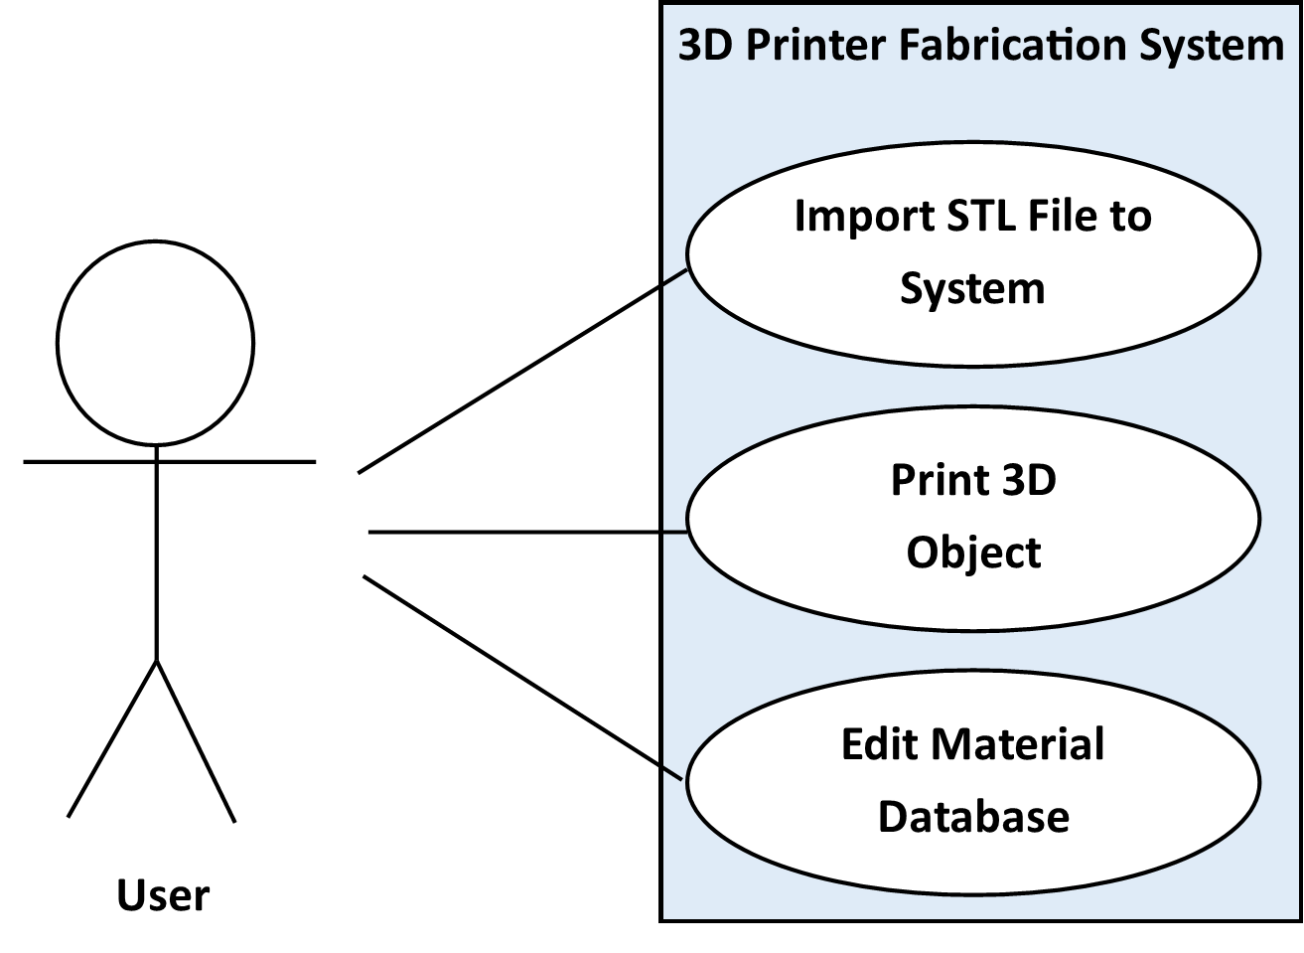
Figure 10-1 Use Case: 3D Printer Operations

11. Feasibility Assessment
This section will go into depth of the feasibility of this project. The assessment is divided into scope analysis, research, technical analysis, and cost analysis. Team Ink3D does not have prior experience with creating or programming a printer, so this assessment is based on our discussions with our sponsor as well as our current research in 3D printing technologies.

11.1 Scope Analysis
Due to the nature of the 3D Printer Fabrication System, there are many critical requirements that must be met in order for the system to perform its main function. We believe that the system has 19 critical requirements that are essential to the system. Of the 19 critical requirements, four of the critical requirements should be easy and quick to implement because of our experience with interfaces and small databases. These are the client interface, the material database, the database interface, and the storing and loading of material records. The bulk of our work will come from taking the read STL file and using the information to create the 3D object. This means the requirements we are most concerned with are:
Customer Requirement 3.14 Slicing Geometry into Thickness Levels
Customer Requirement 3.11 Creating Printing Paths
Customer Requirement 3.3 Generating Machine Instructions
Customer Requirement 3.4 Issuing Machine Instructions
These requirements pose the biggest risk because of our lack in printer programming experience and a lack of strength in linear algebra. The requirements that involve reading and analyzing the STL File may pose a problem, but we have possible solutions that will be further discussed in the (11.2) Research and (11.3) Technical Analysis sections of this document.
All 19 critical requirements are considered as such for one of two reasons. Reason one; the requirement is a step of the printing process. Reason two; the requirement addresses the issue of uncertainty the team faces with not having immediate access to the machine. Despite the number of critical requirements being high, the individual requirements are well defined individual tasks, so we concluded that the project is still feasible.
Three additional requirements of lower importance are listed in Future Items. Because of the significant difference in importance between these requirements and the 19 above, the Future Items are not within our scope at this time and are not imperative to the function of the system.

11.2 Research
The initial research conducted was to understand the traditional 3D printing process because the team has limited knowledge of 3D printing. This initial research was conducted by speaking with our sponsor, Dr. Shiakolas. We held a meeting with Dr. Shiakolas that served as an informative overview of the different types of 3D printing systems and processes used by both commercial and home grown 3D printers. This meeting also included a demonstration of a commercial 3D printer, which aided in our understanding of the operations our system is required to perform. After we acquired a better grasp of the 3D printing process, our team identified the following key areas that would require more research to assess the feasibility of the project: 3D modeling file formats, 3D geometric processing, existing 3D printer instruction sets.
We are required to support a 3D modeling file format called STL. We have researched this format and determined that it will not sufficiently describe multi-material objects but that there is another industry standard file format, AMF, which will meet the requirement of describing multi-material objects. With further research, we have discovered that the conversion from the STL format to the AMF format is a simple process. Because of this simple conversion, it will be feasible to support STL file input.
Research has also been done on the feasibility of processing 3D objects. Our team has discovered that multiple open source tools are available that can process 3D objects described by an STL or AMF file and “slice” those objects into printable layers. Slic3r is one of these 3D printing toolsets that offers this type of processing and even has support for multi-material objects. Slic3r also exposes a command line interface with the intention of being integrated into other systems.
Another technology that our team has researched is the standard instruction sets that current 3D printers use. We have discovered that GCode is a basis for most 3D printers’ instruction sets. GCode is widely supported by the 3D printing community with plentiful documentation available on the Internet. Because there are multiple adaptations of GCode, we need to research further to determine what subset of GCode our system needs to be able to generate for the hardware the Mechanical Engineering team is designing.

11.3 Technical Analysis
There are four main technical concerns involved with developing this 3-D Printer Fabrication System: processing a multi-material 3D model, generating machine specific instructions, sending those instructions to the machine controller, and interpreting the instructions on the machine controller.
To print a 3D object, the object must first be analyzed by the software component of this system and sliced into printable layers. In order to do this, technical knowledge of linear algebra and geometric processing is required. We plan to use Slic3r to alleviate this risk. Although our team still requires a greater technical understanding of 3D geometry processing, utilizing existing processing tools will abstract some of the more complex processing operations and ensure that it is feasible to meet the processing requirements for this product.
Another technical aspect of this system is the interface between the 3D processing software and the 3D printing hardware. The software must generate a set of instructions to deliver to the printer. We know that the machine instruction set will be based off of the industry standard GCode, but the exact subset or extension of GCode to be used is currently unknown. This hurdle can initially be overcome by abstracting the hardware instruction generation operations so that a different code generation implementation can be used for any specific set of GCode.
To add to the technical concerns about the communication between the software and the hardware, the delivery method of the machine instructions to the printer is currently not defined. Some currently existing 3D printing systems sends all the GCode instructions to the printer at once, where they are stored in local memory during the print execution. Other existing systems stream the GCode instructions to the printer throughout the printing process. Because both of these communication methods are implemented in currently existing systems, we know that they are both feasible. Although they are both feasible, the exact communication method to be implemented in our system must be defined.
Once the machine controller has the GCode instructions, it must be able to interpret those instructions to control the printing hardware. There exists numerous 3D printing firmware implementations that are freely available through the online 3D printing community. Because this firmware already exists, interpreting the GCode instructions and controlling printing hardware should be a feasible task. In addition, the 3D printing community is very active and can be a valuable resource in assisting the completion of this task.

11.4 Cost Analysis
We primarily examine two sources for cost in determining the feasibility for the project. First is the incurred cost of any software or productivity requirements. The second is the direct cost associated with any required hardware components.
As a fully open source project, we limit the cost incurred from licensure by utilizing only fully open source software should it be required. Currently, we have not incurred and do not expect to incur overhead costs from software licensure as solutions exist within the free and open source domain. This also satisfies the open source requirement for a project sponsored by a public institution.
Much of the hardware requirement will be satisfied by the mechanical engineering team on their end. For example, the printing bed, interface, and processing machine should be facilitated by the mechanical engineering team. As such, the cost incurred from our hardware requirements is limited to the intermediary machine whose task is to dispatch instructions in real time to the printer interface. This task can be accommodated by Raspberry Pi or Arduino based system on a chip which can be purchased for $50. There may also be periphery hardware linkage required such as cables, interfaces, and possible converters which should not total more than $100.
Given these constraints, the project lies well within the cost boundaries given at this time. Therefore, we conclude that the project is feasible from a cost perspective with significant buffer space for unexpected costs.

11.5 Resource Analysis
For this project, we break the work responsibility into three primary components. Database and interface presentation, data driven processing, and hardware interfacing. Each component is listed from highest coarseness down to most fine grained complexity. Our team consists of two software engineers, a computer scientist, and a computer engineer.
During the skill assessment we determined that we are all quite adept within our given disciplines with minimal overlap. One of the primary skills required for this project will be an understanding of a high performance, lower level language like C. One of our highest scoring marks as a team on the skills assessment was our knowledge of the C language.
At the highest level, our two software engineers’ skills suit the need to develop a scalable and modular system. Given that scalability is critical to the project, these skills put us in a position to fulfill the top level design requirements for the software.
Between our computer engineer and computer scientist, we possess functional knowledge of speed and data sensitive processing. This requirement is critical for the real-time dispatch of machine level commands to the 3D printer interface.
At the hardware interface level, our computer engineer possesses skills in the lowest level processing and hardware interfaces that will be critical in interfacing the intermediary machine to the 3D printer interface. He will also provide interfaces up the chain from hardware to processing, and thenceforth from processing to high level interface.
Our collective skills uniquely position the team to succeed in a project of this scope. There are multiple components on the lowest through highest levels that each team member is uniquely suited to perform.

11.6 Schedule Analysis
We have used several methods to estimate the size and duration of the 3-D Printer Fabrication System. Based on these estimates the team will need to carefully trim the requirements or implement an open source tool to reduce the complexity or lines of code to meet the restricted schedule.

11.6.1 Size Estimate – Function Points
The below tables show the function point complexity and distribution for the 3-D Printer Fabrication System.

Function Points Analysis
Program  Characteristic | Low  Complexity | Moderate  Complexity | High  Complexity | Function Point  Totals
Number of Inputs | 12*3 | 1*4 | 2*6 | 52
Number of  Outputs | 2*4 | 0*5 | 4*7 | 36
Inquiries | 2*3 | 0*4 | 2*6 | 18
Logical Internal  Files | 1*7 | 0*10 | 2*15 | 37
External  Interface File | 0*5 | 0*7 | 1*10 | 10
Unadjusted Function Points |  |  |  | 153
Adjustment Factor |  |  |  | .99
Adjusted Function Point Total |  |  |  | 152
Table 11.1

Influence Multipliers
Characteristics | Effort (0-5)
Data Communications | 3
Distributed Data Processing | 1
Performance | 3
Heavily Used Configuration | 2
Transaction Rate | 1
Online Data Entry | 0
End User Efficiency | 4
Online Update | 0
Complex Processing | 5
Reusability | 4
Installation Ease | 4
Operation Ease | 3
Multiple Sites | 0
Facilitate Change | 4
Total | 34
Value Adjustment Factor | .99
Table 11.2

11.6.2 Effort Estimate – Jones First Order Estimation
The below table shows the schedule estimate for the 3-D Printer Fabrication System using Jones First Order Estimation method.
Jones First Order Estimation
Worst in Class | Average in Class | Best in Class
152^{.48} | 152^{.45} | 152^{.43}
11.2 Calendar Months | 9.6 Calendar Months | 8.7 Calendar Months
Table 11.3

11.6.3 Size Estimate – Lines of Code
The 3-D Printer Fabrication System should have between 6,000 and 10,000 lines of code. The schedule range based on the lines of code expected is detailed in the table below.

Size Estimate – Lines of Code
 | Low Side Estimation | High Side Estimation
Size Estimate | 6,000 Lines of Code | 10,000 Lines of Code
Productivity | 300 Lines of Code | 250 Lines of Code
Effort | 20 Months | 40
Duration of 4 Person Team | 5 Months | 10 months
Table 11.4

11.6.4 Effort Estimate – CoCoMo
The below table details the CoCoMo based estimate for the 3-D Printer Fabrication Syatem.
CoCoMo Estimate
 | Low Estimate | High Estimate
Effort – Person Months | E = 3.0(5)^{1.12}  E= 18.2 Man Months | E = 3.0(10)^{1.12}  E= 39.5 Man Months
Duration – Months | D = 2.5(18.3)^{.35}  D = 7 Months | D = 2.5(18.3)^{.35}  D = 9 Months
Table 11.5

11.6.5 Effort Estimate – Estimate Comparison
Estimate Comparison
Method | Low Estimate | High Estimate
Jones First Order | 8 Months | 11 Months
Lines of Code | 5 Months | 10 Months
CoCoMo | 7 Months | 9 Months
Average | 6.6 Months | 10 Months
Table 11.6

12. Future Items
This section reiterates the requirements in this document that have been deemed “Priority 5 – Future.” These requirements will not be addressed in the prototype version of the product due to various constraints as described in this section.

12. 1 Customer Requirement 3.17 – Monitor Door Switch
12.1.1 Requirement Description: The system shall be able to use a sensor to monitor the 3D printer’s access door. Appropriate action should be taken when the door is opened during printing and when the door is closed when not printing.
12.1.2 Constraint: Uncertainty: The team developing the physical printing hardware is uncertain if the printer will be enclosed with a door or an open-air design. This requirement will take time that will be wasted if the printer uses an open-air design.

12. 2 Customer Requirement 3.19 – Sparsity and Density Controls
12.2.1 Requirement Description: The system shall allow for models to be processed in such a way that the geometry can be simplified or made more complex according to user specifications from any arbitrary model geometry.
12.2.2 Constraint: Team Skills: The team lacks the technical skills to implement this functionality in an efficient manner.

12. 3 Customer Requirement 3.20 – Graphical Object Models
12.3.1 Requirement Description: The system shall display a graphical model of the objects represented by imported STL files. The user will be able to drag the graphical model around on a virtual printer bed in order to specify the location on the printer bed where the object will be printed.
12.3.2 Constraint: Feasibility: It is not feasible to develop a 3D modeling display component given the team’s limited schedule.

